**Document Name:** Sprint 4 Plan

**Product Name:** MuscleMinder

**Team Name:** FitTech Innovators

**Release Name:** MuscleMinder Launch

**Sprint Completion Date**: 6/4/2024

Sprint 4 Plan

### Sprint Goal

* High Priority User Story 4.1 [5 points]: As a user, I want to know if I am over/under-exerting myself on certain days of the week based on my workout.
* Low Priority User Story 4.2 [5 points]: As a user, I want to have my information be stored so I can come back to my chosen plan at a later date.

## Sprint 4 User Stories

* High Priority User Story 4.1 [5 points]: As a user, I want to know if I am over/under-exerting myself on certain days of the week based on my workout.
  + Task 4.1.1: Specify which workouts are in which split (push/pull/legs)
  + Task 4.1.2: Implement a menu to implement your workout schedule for your workout split across a certain amount of days.
  + Task 4.1.3: Assign each workout to what split they would belong to and add the information to the database.
  + Task 4.1.4 Shift the workout validation to work on the backend.
* Low Priority User Story 4.2 [5 points]: As a user, I want to have my information be stored so I can come back to my chosen plan at a later date.
  + Task 4.2.1: Add cookies to the project to enable the user to save their workout (5 hours)

**Task assignment:**

| Qays | Riksean | Safwan | Alexander | Jack |
| --- | --- | --- | --- | --- |
| 4.2.1 | 4.1.3 | Writing Docs  4.1.1 | 4.1.2 | 4.1.4 |

**Burn-up Chart**

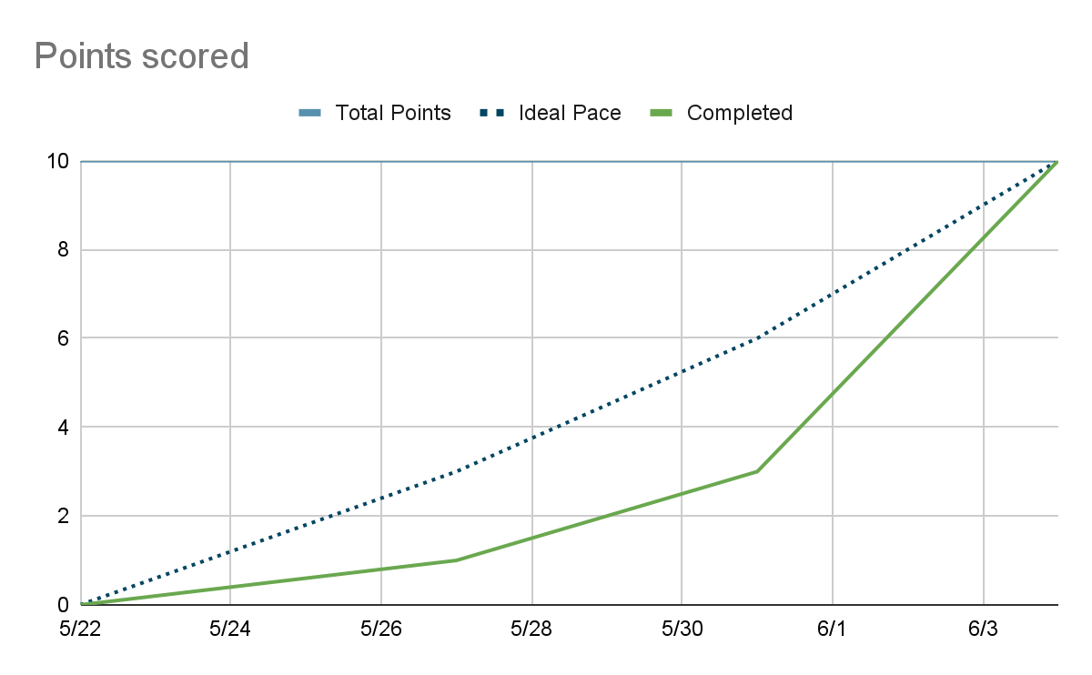

| **Titled User Stories,** | **Tasks Not Started,** | **Tasks In Progress,** | **Tasks Finished** |
| --- | --- | --- | --- |
| * 4.1 [5 points]: As a user, I want to know if I am over/under-exerting myself on certain days of the week based on my workout. * 4.2 [5 points]: As a user, I want to have my information be stored so I can come back to my chosen plan at a later date. |  | 4.1.2 | 4.1.4  4.2.1  4.1.1  4.1.3 |

**Scrum Times:**

**Monday: 1:30 pm - 2:15pm**

**Wednesday: 1:30pm - 2:30pm (TA Meeting)  
Wednesday: After TA meeting**

**Saturday: 1:00pm - 2pm**